|  |
| --- |
| NAKSYS |
| FrameReader Specifications |
| Design Document |
|  |
| **Thirumugam & Viswanath** |
| **4/6/2018** |

|  |
| --- |
| Describes the design and modules of the FrameReader Embedded system. Also provides the technical details of analysis results. |

Table of Contents

1. Introduction 3

1.1. Existing Design 3

1.1.1.Sensor Board / Slave 3

1.1.2.Master 3

1.1. Why new design is required? 3

2. New Design 4

2.1. Code 4

3. Modules 4

3.1. Bluetooth 4

3.2. RTC 4

3.3. SD card for data storage 4

3.4. Compass 4

3.5. Photodiodes & related components 4

3.6. Display 4

4. Technical Details 5

4.1. PIC 4550 5

4.2. Arduino 5

4.3. Analog to Digital Converter 5

4.4. Bluetooh 5

4.5. Encasing 5

# Introduction

FrameReader is a measurement and data logging device used for generate photometric reports in conformance with the ICAO & FAA standards

This document is focused on the hardware (embedded PCB) part

## Existing Design

The FrameReader Version 2.1 (Aug 2016) consist of a hardware and software.

Software: Used for collecting the reports from SD card and generating the reports and also used for analysis.

Hardaware: It consist of two major parts as described below

### 1.1.1.Sensor Board / Slave

Here after in this document “Sensor Board” will be used to describe this part.

It consist of a array/matrix of photodiodes with a circuit to give output in lumens.

### 1.1.2.Master

It has a LCD display and the control interface(buttons) to send commands to the slave to acquire data from sensors.

## Why new design is required?

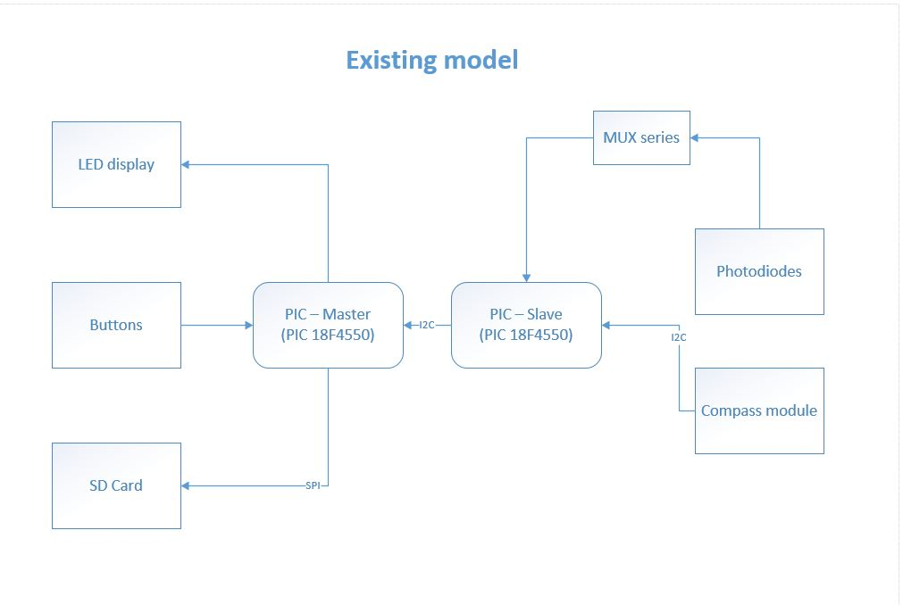

Figure - Flow chart of Existing design

Two operators are required to make a measurement.

To transfer the measurement data, SD card has to be manually removed and connected to the system with Frame Reader software for further analysis.

# New Design

The existing master PCB and Sensor Board will be integrated into a single system to be conveniently used by a single operator.

A Bluetooth module will help in the data transfer without any manual intervention.

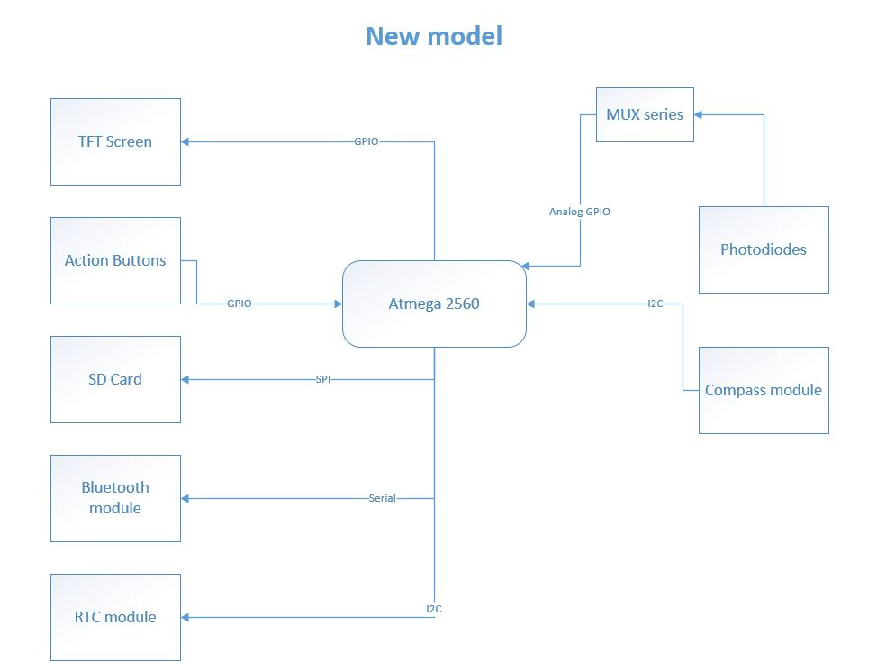

Figure - New Frame reader flow design

## Code

Workflow diagram(Flow chart)

# Modules

## Bluetooth

The Bluetooth module (HC 05) is a SPP (Serial Port Protocol) module, designed for wireless serial connection setup

Serial port Bluetooth module is fully qualified Bluetooth V2.0+EDR (Enhanced Data Rate) 3Mbps Modulation with complete 2.4GHz radio transceiver and baseband, Which will help in transferring the data that has to be sent for the ‘Frame reader’ software to obtain and produce results out of it.

The **data archive logic** for the system will archive the file with date and time stamp once the data has been transmitted through Bluetooth with date stamp to the file name

## RTC

The RTC (Real Time Clock) module used is DS3231 which is a re chargeable battery powered (LIR2032) which can set with the real time and the module will retain the date and time, it also has capability to adjust to leap years.

The RTC module will be helpful in providing the time and date stamp along with each measurement and also or the data archive logic which has been explained earlier.

## SD card for data storage

The SD card module along with sd card will help in storage of sensor data needed for report locally it has to be sent over when needed. The SD card is present in the existing model but with the new model the memory has been increased to humongous 8GB.

## Compass

The compass module (LSM303DLHC) is a combination of accelerometer and magnetometer module which provides magnetic direction and roll, pitch, yaw in respect to the orientation

The information from the compass module will be used to identify magnetic direction and proper orientation of the portable sensor board which will result in better sensor data.

## Photodiodes & related components

The photodiodes are the heart of the system which will fulfill the purpose of the system by collecting data from the lights. These photodiodes will have spectral response characteristics similar to that of human eye

The photodiodes circuit output will be multiplexed with 4067 and 4052 multiplexer since there are 45 photodiodes whose values has to be obtained and manipulated by the microcontroller, the MUX will help in cutting down the ports needed by the microcontroller to obtain data

## Display

A TFT screen will be integrated with the system which will help the user with the details to orient and position the device with direction, roll, and pitch data

PS: This module will be upgraded in the future version.

## Microcontroller

The microcontroller used in the existing system is **PIC 18F4550** whose specifications has been explained below. A combination of two microcontrollers helps in acquiring the data, storing and responding to the user based upon inputs.

The existing model of microcontroller which has two PIC will be replaces with one **ATmega 2560** whose specifications has also been discussed below

# Technical Details

## PIC 18F4550 Microcontroller

The microcontroller, which is the brain of the system, is a 40 pin IC with dip package, the datasheet can be found here for further details



Photo

Attach DataSheet as object.

## Atmega 2560 (Arduino)

The ATmega 2560 is a 100 pin microcontroller in SMD package, the data sheet for further details can be found here



In the new model Atmega 2560 is programmed and integrated in place of two pic184550 microcontrollers with more SRAM and program memory

|  |  |  |
| --- | --- | --- |
| **Microcontrollers** | **Arduino Mega 2560** | **PIC18F4550** |
| Flash memory | 8Kb | 2.048Kb |
| SRAM | 8 Kb | 2.048 Kb |
| EEPROM | 4 Kb | 0.256 Kb |
| Clock Speed | 16 MHz | 8 MHz |

## Analog to Digital Converter

## Bluetooth

## Encasing